A MINI PROJECT REPORT

ON

Address Book

Submitted in partial fulfillment of the requirement of the University of Mumbai for the Course

### Cloud Computing Lab

In

### Computer Engineering (VIII SEM)

Submitted By

### Vansh Shah(19202009)

**Jash Doshi(19202007)**

**Aashay Gogri(19202010) Yash Mehta (19202005)**

Subject Incharge

### Prof. Deepak Khachane

**Department of Computer Engineering**

### A. P. Shah Institute of Technology Thane - 400615

**UNIVERSITY OF MUMBAI**

### Academic Year 2021 - 22

Department of Computer Engineering

A. P. Shah Institute of Technology Thane - 400615

# CERTIFICATE

This is to certify that the requirements for the project report entitled ‘**Online Examination Portal**’ have been successfully completed by the following students:

|  |  |
| --- | --- |
| **Name** | **Roll No.** |
| Vansh Shah | 58 |
| Jash Doshi | 29 |
| Aashay Gogri | 24 |
| Yash Mehta | 32 |

in partial fulfillment of the course Cloud Computing Lab in Computer Engineering (VIII SEM) of Mumbai University in the Department of Computer Engineering, A.P. Shah Institute of Technology, Thane – 400615 during the Academic Year 2021 – 22.

#### (Prof. Deepak Khachane)

**Subject Incharge**

Department of Computer Engineering

A. P. Shah Institute of Technology Thane - 400615

# PROJECT APPROVAL

This project entitled “Address Book” by Vansh Shah, Jash Doshi, Aashay Gogri and Yash Mehta is approved for the course Cloud Computing Lab in Computer Engineering (VIII sem) of Mumbai University in the Department of Computer Engineering.

Subject Incharge: Prof. Deepak Khachane

Date:

Place: Thane

Department of Computer Engineering

A. P. Shah Institute of Technology Thane - 400 615

# DECLARATION

We declare that this written submission for the Cloud Computing Lab mini-project entitled “Address Book” represents our ideas in our own words and where others' ideas or words have been included, we have adequately cited and referenced the original sources. We also declare that we have adhered to all principles of academic honesty and integrity and have not misrepresented or fabricated or falsified any ideas/data/fact/source in our submission. We understand that any violation of the above will cause disciplinary action by the institute and also evoke penal action from the sources which have not been properly cited or from whom prior permission has not been taken when needed.

Project Group Members:

Vansh Shah

Jash Doshi

Aashay Gogri

Yash Mehta

Place: Thane

**Table of Contents**

|  |  |  |
| --- | --- | --- |
| **Sr.No** | **Topic** | **Page No.** |
| 1. | Abstract | 5 |
| 2. | Problem Definition | 6 |
| 3. | Introduction | 7 |
| 4. | Description | 9 |
| 5. | Literature Survey | 12 |
| 6. | Implementation | 14 |
| 7. | Learning Outcomes | 29 |
| 8. | References | 30 |
| 9. | Acknowledgment | 31 |

## Abstract

A cloud is simply a location at the other end of an internet connection where you can access apps and services as well as securely store your data. A cloud environment requires no effort on the user's part to maintain or operate, and its size is virtually infinite, so there is no need to be concerned about it running out of space. Cloud-based applications and services can be accessed from anywhere in the world via an internet connection. The cloud has become so pervasive in our daily lives that most people are unaware of its presence. In fact, without access to the cloud, many people's lives would be drastically altered. There would be no Facebook, Twitter, Gmail, or other social media platforms.

The cloud has changed the business landscape, with millions of organisations around the world relying

on cloud services for everything from document creation and backup to social CRM and accounts. Cloud

computing allows for instant scaling, quick implementation, no upfront costs, and maintenance-free

services with excellent security. Because cloud services can be accessed from anywhere, our project goal

was to deploy an application on the AWS Cloud environment that is not system dependent and can be run

on any device. We used AWS Cloud services such as PHP, EC2 Instance, and MySQL in this project. We

created a project that includes a website for storing people's addresses.

## Problem Definition

To implement an address book which is user friendly and will restrict the user from accessing other user’s data and to store the details of the user after verifying basic requirements such as basic validations.

## Introduction

As the name specifies "Address book" is software developed for managing various details of persons. Through this address book, we can handle the details of persons properly which can not be possible to keep in mobile as there is less space in the detail section. This particular project deals with the problems of managing the details of the person and avoids the problems of losing the details.

Identification of the drawbacks of the existing system leads to the designing of a computerized system that will be compatible with the existing system with the system which is more user-friendly and more GUI oriented. We can improve the efficiency of the system, thus overcoming the drawbacks of the existing system.

· Less human error

· Strength and strain of manual labor can be reduced

· High security

· Data consistency

· Easy to handle

· Easy data updating

· Easy record keeping

## Description

The cloud services used in this project have different functionalities which are explained below.

* **EC2 Instance:** Amazon Elastic Compute Cloud (Amazon EC2) provides the most comprehensive and deep compute platform, with over 500 instances and a selection of the most recent processor, storage, networking, operating system, and purchase model to help you best match the needs of your workload. They are the first major cloud provider to

support Intel, AMD, and Arm processors, as well as the only cloud to offer on-demand EC2 Mac instances and 400 Gbps Ethernet networking. They provide the best value for money for machine learning training as well as the lowest cost per inference instance in the cloud. AWS hosts more SAP, high performance computing (HPC), machine learning (ML), and Windows workloads than any other cloud.

EC2 enables users to access reliable, scalable infrastructure on demand, scale capacity within minutes with a SLA commitment of 99.99 percent availability, optimize performance and cost with flexible options such as AWS Graviton-based instances, Amazon EC2 Spot instances, and AWS Savings Plans, and provide secure compute for all applications.

Technology Stack –

* + Cloud Platform – AWS
  + MySQL
  + PHP

EC2 Use Cases:

* + **Hosting environments**

One of the foremost uses of EC2 is for hosting a variety of applications, software and websites on the cloud. Users are even hosting games on the cloud, turning the servers on and off when needed. And the best part of this [dynamic and scalable](https://www.awsforbusiness.com/components-aws-elastic-cloud-compute/) environment is that its compute capacity can grow along with the need of the application. This in turn ensures the best quality service for all end users at all times. Companies like Netflix, Reddit, and Nintendo are proof of the EC2 hosting success.

* + **Development and test environments**

The scalable nature of EC2 means that organizations now have the ability to create and deploy large scale testing and development environments with unprecedented ease. The Amazon cloud does away with any heavy upfront investments for hardware, all the while providing a scalable solution.

* + **Backup and disaster recovery**

Companies are leveraging EC2 as a medium for performing disaster recovery for both active and passive environments. The fact that the Amazon Elastic Compute Cloud can be turned up quickly in case of an emergency, means that businesses have access to a faster failover with minimal downtime for their applications.

* **MySQL:** MySQL is an Oracle-backed open source relational database management system (RDBMS) based on Structured Query Language (SQL). MySQL runs on virtually all platforms, including Linux, UNIX and Windows. Although it can be used in a wide range of applications, MySQL is most often associated with web applications and online

publishing. MySQL is an important component of an open source enterprise stack called LAMP. LAMP is a web development platform that uses Linux as the operating system, Apache as the web server, MySQL as the relational database management system and PHP as the object-oriented scripting language (Sometimes Perl or Python is used instead of PHP). MySQL is based on a client-server model. The core of MySQL is MySQL server, which handles all of the database instructions (or commands).

## Literature Survey

#### Optimizing MySQL database system on information systems research, publications and community service: K. I. Satoto, R. R. Isnanto, R. Kridalukmana and K. T. Martono,2016

Many of the most popular and highly-trafficked websites in the world are built on MySQL database. Process optimization is done on the design of the database system. Database design plays an important role in determining system performance. This virtual table process to be performed by the system to be faster.

#### A Comparative Analysis of the Performance of Implementing a PHPApplication Based on the Microservices Architecture, for Various AWS EC2 Instances

**D. Kubiak and W. Zabierowski,2021**

The article summarizes the performance of three AWS EC2 instances for various test cases running on a PHP, microservices-based application. The analysis' goal was to show what procedures should be followed when selecting an acceptable environment for the deployed application.

#### Amazon EC2

Amazon Elastic Compute Cloud (Amazon EC2) offers the broadest and deepest compute platform, with over 500 instances and a choice of the latest processor, storage, networking, operating system, and purchase model to help you best match the needs of your workload. We are the first major cloud provider that supports Intel, AMD, and Arm processors, the only cloud with on-demand EC2 Mac instances, and the only cloud with 400 Gbps Ethernet

networking. We offer the best price-performance for machine learning training, as well as the lowest cost per inference instance in the cloud. More SAP, high performance computing (HPC), ML, and Windows workloads run on AWS than any other cloud.

#### My SQL

MySQL server is available as a separate program for use in a client-server networked environment and as a library that can be embedded (or linked) into separate applications. MySQL operates along with several utility programs which support the administration of MySQL databases. Commands are sent to MySQLServer via the MySQL client, which is installed on a computer. MySQL was originally developed to handle large databases quickly. Although MySQL is typically installed on only one machine, it is able to send the database to multiple locations, as users are able to access it via different MySQL client interfaces. These interfaces send SQL statements to the server and then display the results.

* **PHP**

PHP is a server-side scripting language that is embedded in HTML. It is used to manage

dynamic content, databases, session tracking, even build entire e-commerce sites.

It is integrated with a number of popular databases, including MySQL, PostgreSQL, Oracle,

Sybase, Informix, and Microsoft SQL Server.

## Implementation

The following steps and screenshots depict the implementation of deployment of the application on AWS Cloud environment.

STEPS:

Step1: Select the Amazon Machine Interface (AMI)

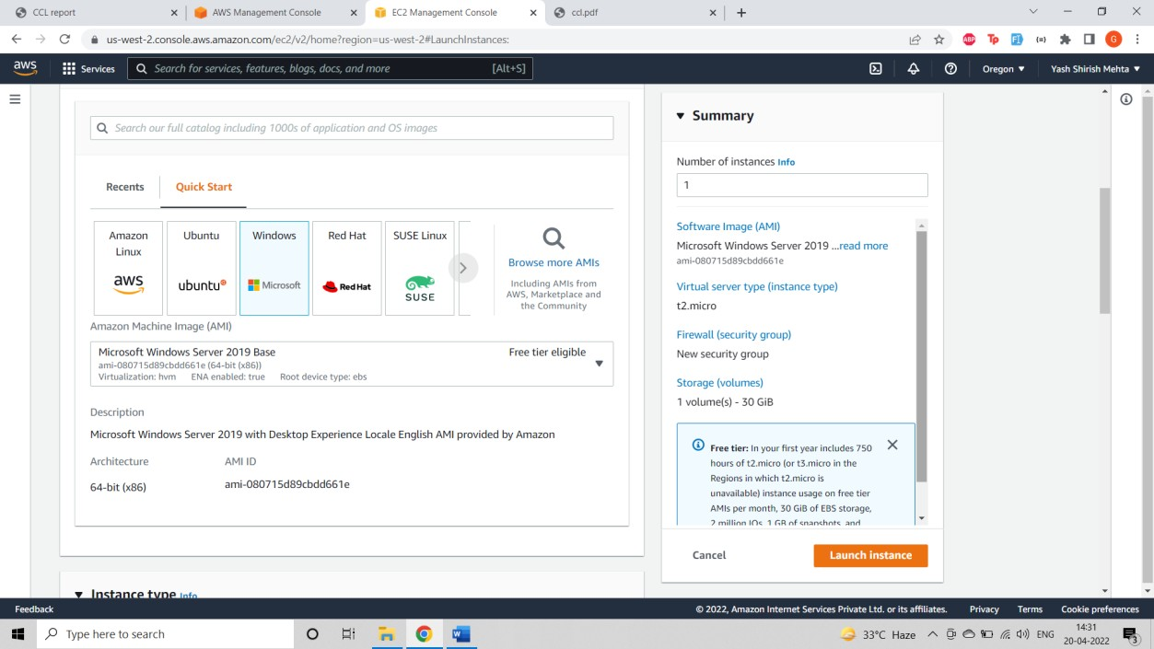

Step 2: Select RDP, HTTP, HTTPS and create Key Pair.

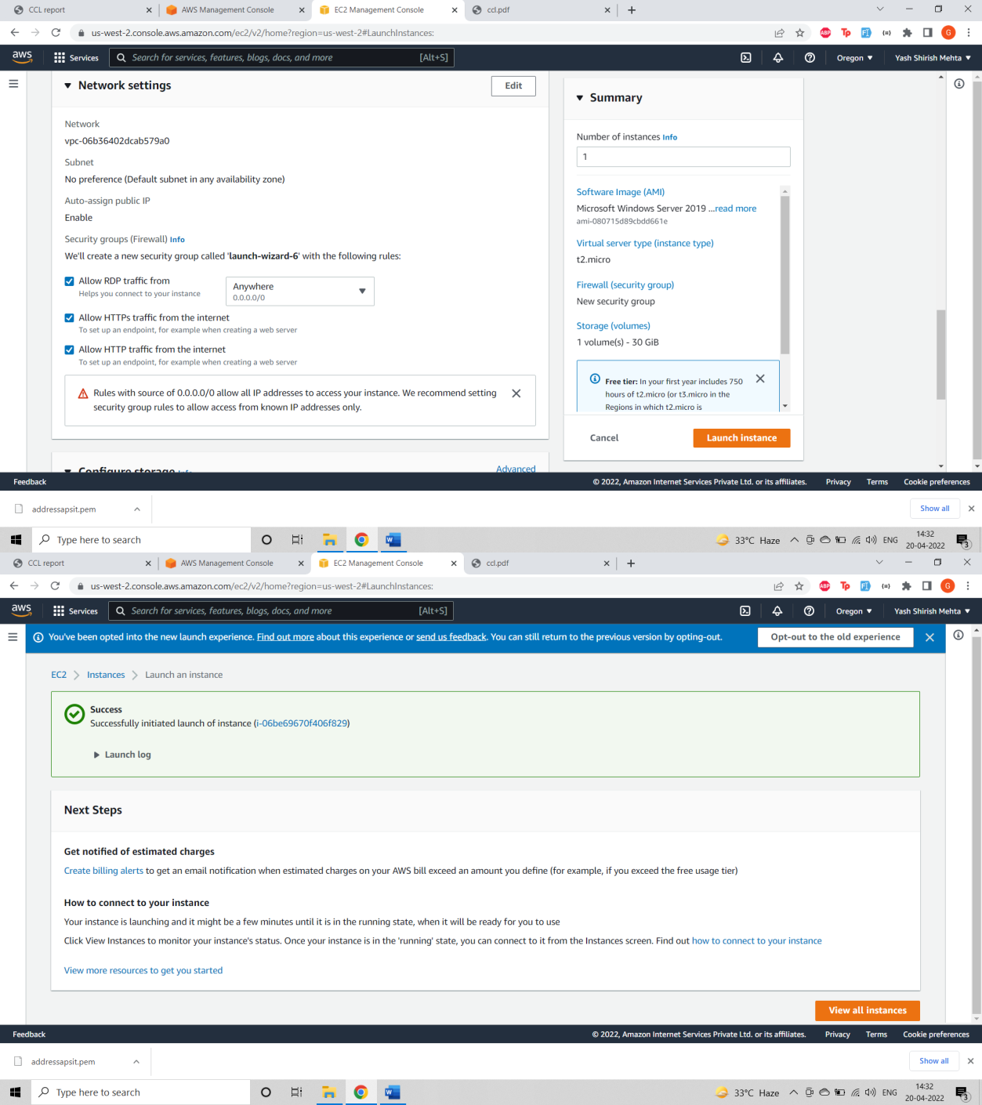

Here in the above picture Instance is successfully launched

Step3: Download the remote desktop file

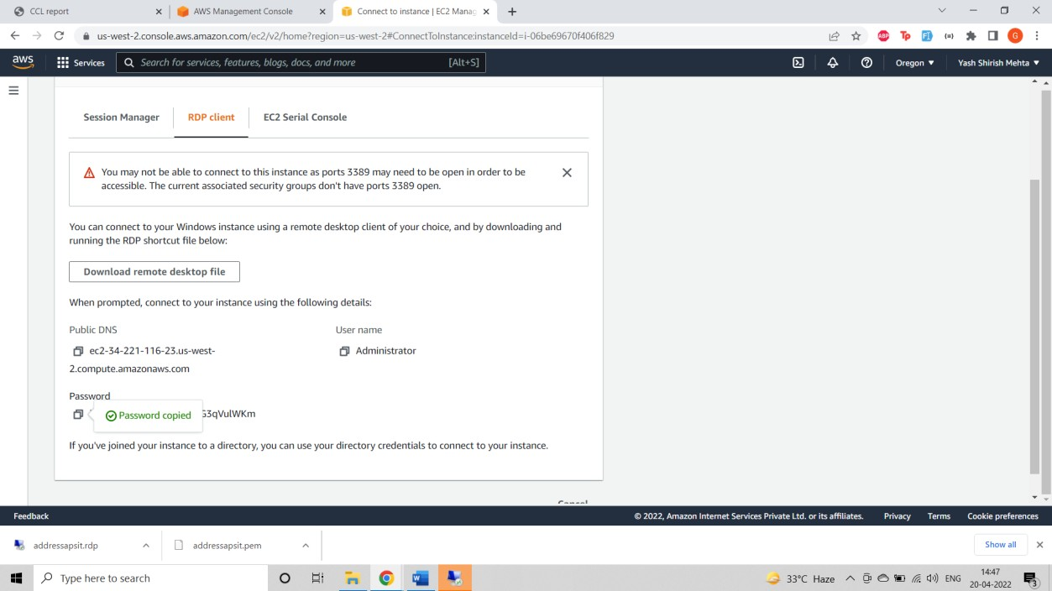

Step4: Generate password and then enter into the remote desktop



Step 5:Install XAMPP and create database and then put the code in htdocs and the project will run successfully

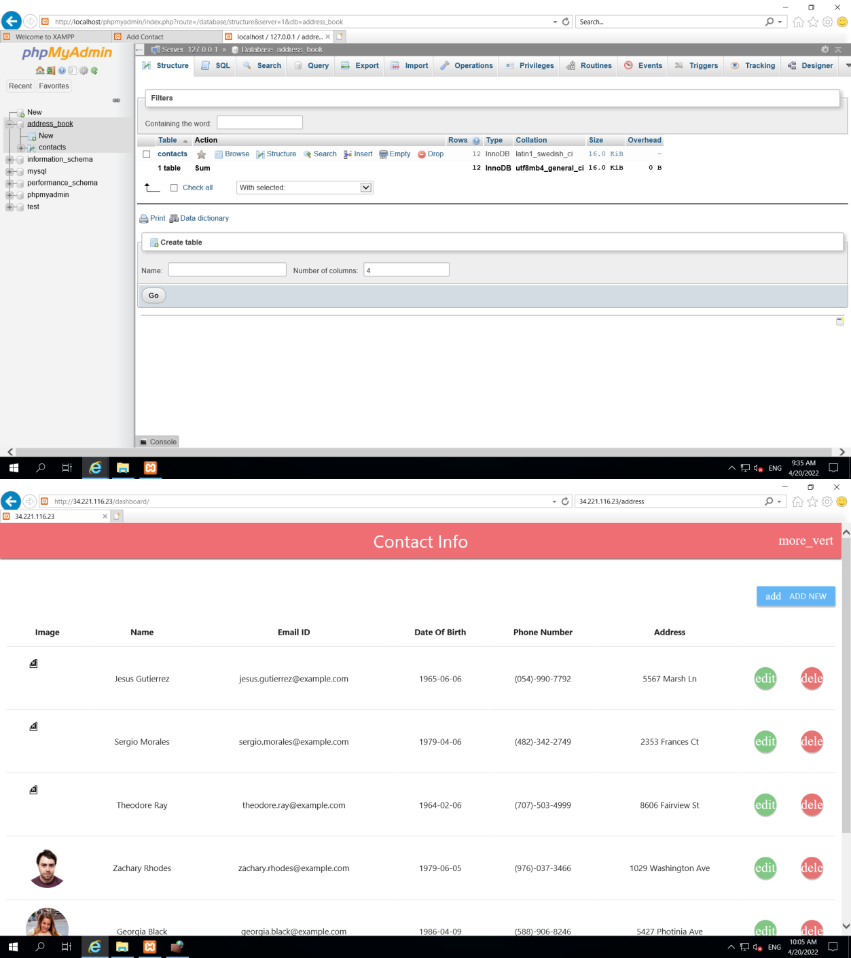

## Learning Outcomes

The main aim of this project was to understand the concepts of cloud computing and implement them by the means of a project. During the course of development of this project we learned to use the AWS Cloud console in terms of using the different services provided by AWS. We have studied and implemented the following concepts and used the cloud services:

* Software as a Service
* EC2
* PHP
* MySQL

## References

* <https://aws.amazon.com/ec2/>
* https://aws.amazon.com/application-hosting/
* <https://aws.amazon.com/websites/>

## Acknowledgement

We have deployed our website on AWS Cloud with help of guidelines provided by the AWS Account. This was possible only by the support of our subject incharge and our department to whom we express our gratitude.